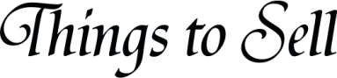
Item |  | Value |  | Place to Sell |  | Asking Price |  | Selling Price

