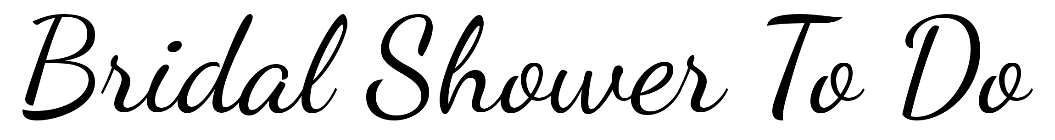

|  |  |  |  |
| --- | --- | --- | --- |
| To Do | Due By | Assigned To | ✓ |
|  |  |  |  |
|  |  |  |  |
|  |  |  |  |
|  |  |  |  |
|  |  |  |  |
|  |  |  |  |
|  |  |  |  |
|  |  |  |  |
|  |  |  |  |
|  |  |  |  |
|  |  |  |  |
|  |  |  |  |
|  |  |  |  |
|  |  |  |  |
|  |  |  |  |
|  |  |  |  |
|  |  |  |  |
|  |  |  |  |
|  |  |  |  |
|  |  |  |  |
|  |  |  |  |
|  |  |  |  |